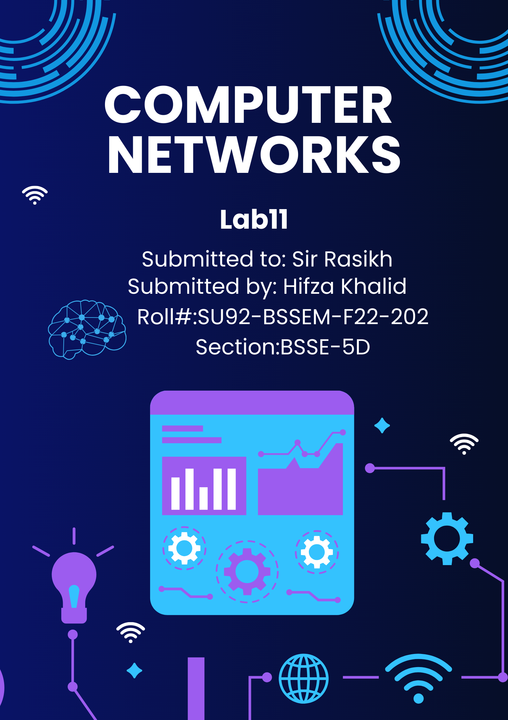

# **Lab 11**

**Research on Super-Netting, DHCP, VLAN & DNS**

# **Lab 11 - Task**

## Task 1;

**What is “DHCP, VLAN & DNS”, explain with Example**

**(draw structure in cisco)**

* **DHCP (Dynamic Host Configuration Protocol)**

DHCP is a network protocol used to automatically assign IP addresses to devices on a network. It helps eliminate the need for manually assigning IP addresses, ensuring that each device gets a unique and valid IP address dynamically.

**Example:** When you connect a device, like a laptop, to a network (e.g., Wi-Fi), the laptop sends a request to the DHCP server for an IP address. The DHCP server responds with an available IP address, subnet mask, default gateway, and DNS server addresses. This automatic process simplifies network management.

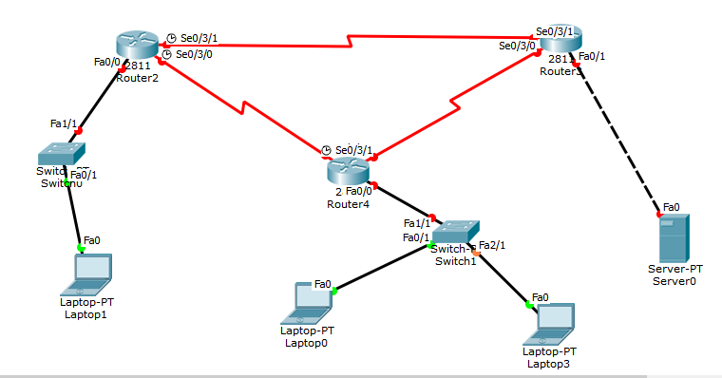

* **VLAN (Virtual Local Area Network)**

A VLAN is a logical subdivision of a physical network, enabling you to segment devices into different broadcast domains. VLANs are used to separate devices for security, performance, or organizational purposes, even if they are on the same physical network.

**Example:** Consider a company with three departments: HR, Sales, and IT. Each department is connected to the same physical network but should be isolated for security and efficiency. By configuring VLANs, each department can be placed in its own VLAN (**VLAN 10 for HR, VLAN 20 for Sales, VLAN 30 for IT**). Devices in different VLANs can't communicate directly unless a router or Layer 3 switch is used to route traffic between them.

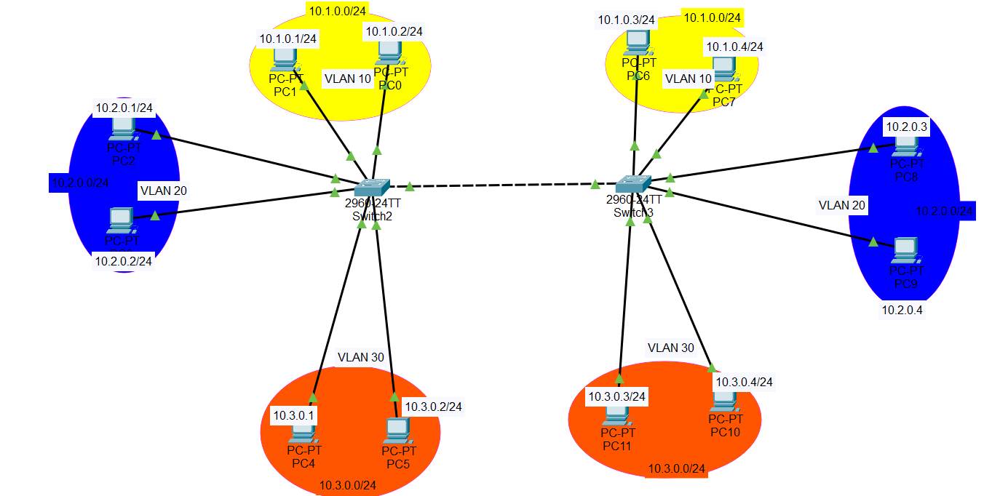

* **DNS (Domain Name System)**

DNS is a system that translates human-readable domain names (like www.example.com) into IP addresses (like ***192.168.1.1***). It acts as a phonebook for the internet, allowing users to access websites using easy-to-remember names instead of numeric IP addresses.

**Example:** When you type www.google.com into your browser, your computer queries a DNS server to resolve www.google.com into an IP address like 142.250.64.46. Once the IP address is returned, your browser can connect to the server hosting Google’s website.

DNS network simulation in various configurations using Packet Tracer

1. Single DNS server and a web server.

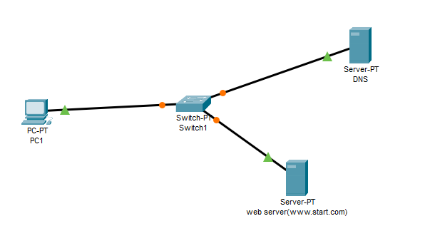

1. **Multiple DNS servers and one web server.**

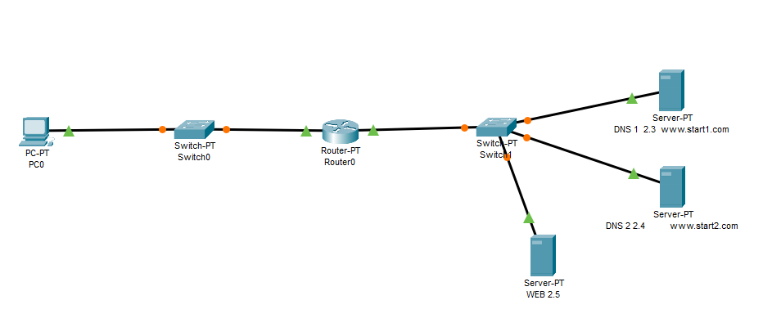

1. **Hierarchical DNS implementation using various levels of DNS servers and web servers accordingly.**

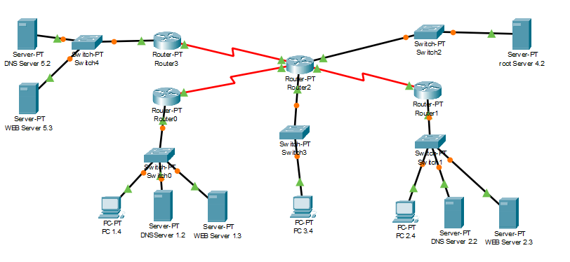

**Conclusion:**

* **DHCP** automatically assigns IP addresses to devices.
* **VLAN** segments a network into different logical groups for security and performance.
* **DNS** translates domain names into IP addresses for easier access to websites.